How to Use Level of Details Expressions to Create a Monthly Profit KPI

Count the numbers of days that are profitable

Drag Order date to the rows field and select discrete and drag profit to the text

Create a calculated field to find the profitable days for each month

**Profit per day**

**{ FIXED [Order Date]:SUM([Profit])}**

Drag Profit per day to the text marks card.

Create a calculated field to categorize the days as Profitable, Highly Profitable or non profitable

**Profitablility Level**

**IF [Profit per day]>200 THEN 'Highly Profitable'**

**ELSEIF [Profit per day]>0 THEN 'Profitable'**

**ELSE 'Unprofitable'**

**END**

Drag the profitability level to the rows column to verify if the day was profitable unprofitable or highly profitable.

To create the view, open a new work sheet

Drag year order date to the Columns and Extend it to months

Drag Profitability level to the Rows shelf and also to the colours shelf.

To view the number of days that are profitable right click the order date and drag it to the rows shelf and select count distinct.

Control click the CNTD(Order Date) and drag it next to it.

On the first CNTD(Order Date) select Area on the marks card and on the second select line.

Create a Dual axis and synchronize the axis.

Create a calculated field for the Tooltip

**Month**

**DATENAME('month', [Order Date])**

Drag The field to the tooltip and edit the tool tip as follows

**In <ATTR(Month)> <YEAR(Order Date)> there were <CNTD(Order Date)>**

**<Profitablility Level> Days**

**Create a parameter as follows.**

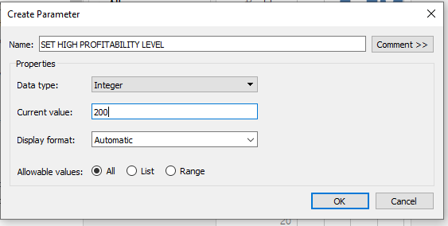

And edit the Profitability level calculated field.

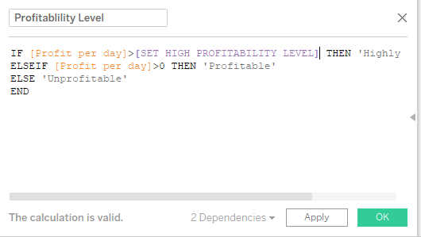

Create a dashboard as desired